
Coaches Handbook

Introduction
The purpose of this handbook is to support and improve the coaching experience by highlighting a structured pathway to develop individuals - coaches and players alike.
To that end we strive to:
- Create a Player Centred, Development driven environment
- Embody the Core Values of Rugby through promotion and example
- Ensure all players have equal opportunity to develop and take part, including the half game rule
- Create opportunities for coaches to develop through RFU CPD courses and working with others within the club Contents
- Rugby Core Values
- Coaching Standards
- Courses and Development Guide
- Age Grade Variations
- Skills Ladder
- Safeguarding
- RugbySafe
- The Coaching Week Checklists
- MEAP
- Useful Links
Rugby’s Core Values
Rugby’s values of Teamwork, Respect, Enjoyment, Discipline and Sportsmanship are what make the game special for those who enjoy the environment and culture they create. They define the game and define England Rugby.
Teamwork is essential to our sport. We welcome all new team members and include all because working as a team enriches our lives. We play selflessly: working for the team, not for ourselves alone, both on and o! the "eld. We take pride in our team, rely on one another and understand that each player has a part to play. We speak out if our team or sport is threatened by inappropriate words or actions.
Respect forms the basis of our sport. We hold in high esteem our sport, its values and traditions and earn the respect of others in the way we behave. We respect our match officials and accept our decisions. We respect opposition players and supporters. We value our coaches and those who run our clubs and treat clubhouses with consideration.
Enjoyment is the reason we play and support rugby union. We encourage players to enjoy training and playing. We use our sport to adopt a healthy lifestyle and build life skills. We safeguard our young players and help them have fun. We enjoy being part of a team and part of the rugby family.
Discipline underpins our sport. We ensure that our sport is one of controlled physical endeavour and that we are honest and fair. We obey the laws of the game, which ensure an inclusive and exciting global sport. We support our disciplinary system, which protects our sport and upholds its values. We observe the sport’s laws and regulations and report serious breaches.
Sportsmanship is the foundation upon which rugby union is built. We uphold the rugby tradition of camaraderie with teammates and opposition. We observe fair play both on and off the pitch and are generous in victory and dignified in defeat. We play to win but not at all cost and recognise both endeavour and achievement. We ensure that the wellbeing and development of individual players is central to all rugby activity

Coaching Standards
Coaches Will:
Provide a safe and enjoyable environment, which challenges players to develop
Ensure all players receive equal participation
Create sessions that encourage a wide range of skills, equipping each player with the ability to play in multiple positions
Develop a positive, open relationship with teams that supports feedback to help with their personal development
In order to be an active coach the following are required:
- A valid RFU DBS check completed
- eLearning Modules
- TackleSafe
- Headcase
- Introduction to Safeguarding
- Read and Commit to the Codes of Practice.
Best Practice also includes:
- England Rugby Coaching Award (ERCA)
- Play it Safe RFU Course
- Active annual engagement in CPD courses

Continuous Personal Development
Why CPD?
- CPD benefits all members of Burnham on RFC.
Specifically:
- Coaches maintain and enhance their knowledge of the game, whilst being effective at delivering quality coaching
- Improves coaches knowledge of the Age Grade requirements
- Opens routes into new training approaches and skill sets
- Allows connections with other coaches operating at the same standard, meaning they are keeping pace with their contemporaries and sharing good practice.

How to Book a Course
All courses can be found via the England Rugby website. Book by logging into your GMS account.
Any course fees will be reimbursed by the club.

Continuous Personal Development – Required Annually

eLearning: Headcase
This 30 minute eLearning course explains what concussion is, how it happens and what individuals can do to help players avoid injury and return safely to play following a concussion eLearning: Introduction to Safeguarding
This 30 minute eLearning course is for anyone working in rugby union who is providing supervised or unsupervised instruction to have a basic understanding of safeguarding.

eLearning: TackleSafe
This eLearning course will support players to become more confident and confident in the tackle through safe and effective coaching. Competence in tackling and taking a tackle is critical in developing a safer and more enjoyable game. Recent studies have shown that many injuries result from tackle situations, so it is essential that this aspect of the game must be coached, officiated and performed by players with due care and attention.

Continuous Personal Development Desirable

England Rugby Tag Rugby
Aimed at those coaching U6- U8 Tag Rugby, this course focuses on how to develop players movement skills, to coach through game zone/ skill zone approach, game management and refereeing. It will explore the Tag Rugby rules and the core skills needed to play Tag Rugby.

England Rugby First Contact Rugby
Aimed at coaches, referees and teachers new to contact rugby, which starts at the U9 age group. It will help you understand how to safely and effectively coach and referee the scrum and tackle and also how to utilise fun, game zone/ skill zone based approach.

Play It Safe
This course is for any volunteer, coach or match official who is working or has responsibility for children and vulnerable adults within rugby. Identifying best practice, it provides information and guidance on the responsibilities and support available for ensuring children and vulnerable adults are safeguarded appropriately.

Continuous Personal Development – Best Practice
Principles of Scrummaging
This course explores the England Rugby principles of scrummaging and is designed to help coaches, match officials and volunteers explore recent developments in scrum coaching.
Principles of the Lineout
This course explores the England Rugby principles of lineout and is designed to help coaches, match officials and volunteers explore recent developments in lineout coaching.
Developing England Players Skill Development
Free course available in the Summer. Aimed at U14U18 Coaches
England Rugby Coaching Award (ERCA)
This course is an entry point for coaches working with players of U12 and above, it is tailored to the needs of the players you are coaching. It provides coaches with the knowledge, skills and attributes to effectively coach young players and adults.
England Rugby Refereeing Award (ERRA)
This course is the entry point for those wishing to referee the 15 a side game.

Age Grade Variations
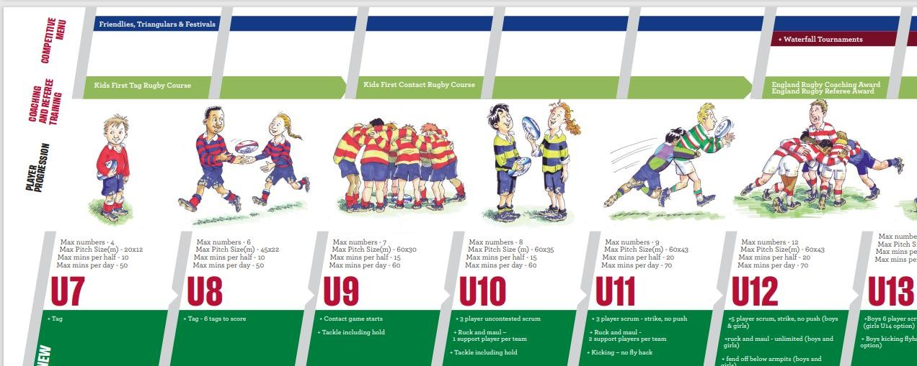

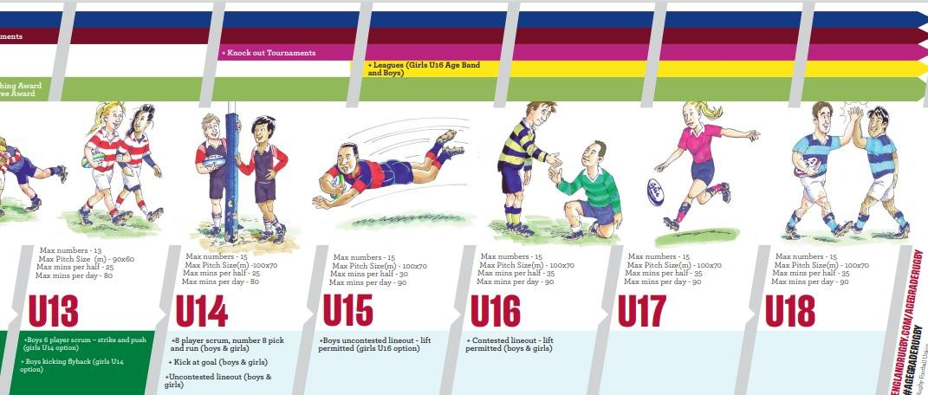

Safeguarding
Everyone shares the responsibility for safeguarding and creating safe environments in rugby union whether as a parent, coach, spectator or club official.
Children, who are anyone under the age of 18, must be cared for in the correct manner, as set out in the RFU Safeguarding Children Policy.
Coaches must complete the following:
- Complete the eLearning module on
Safeguarding (every season)
- Hold a valid DBS, completed through the RFU
- Attend and complete “Play it Safe” as soon as possible.
- Be aware of Regulation 21, which details procedures on dealing with abuse allegations and breaches of the Safeguarding Policy
- Be aware of the club’s safeguarding policy found on the website and in the clubhouse, which outlines specific safeguarding concerns for Burnham on Sea RFC beyond the RFU general policy
- Know who the Club Safeguarding Officer is and their contact details (see the MEAP)

RugbySafe
RugbySafe is about player safety and wellbeing, putting player welfare at the heart of the game and covering how the game should be organised and managed to ensure that rugby is played in a safe and enjoyable environment.
Coaches have a responsibility, with support from the RugbySafe lead, to take preventative action to ensure a safe, enjoyable playing environment.

In order to do that, each coach should:
- Check that there is a designated first aider at training and matches
- Check the weather conditions and assess whether it is appropriate to play given players age and ability.
- Communicate to parents about preparation, for example additional water or correct clothing
- Assess whether children are appropriately prepared for play
- Check playing surfaces for any potential hazards, including the hardness of pitches or standing water
- Check all equipment is suitable for use.
- Be aware of the Medical Emergency Action Plan, including the location of any emergency equipment.
- Have a register of who is at your session.

The Coaching Week
Wednesday
Communicate with parents about weekend plans (fixtures secretary will confirm with individual clubs).
Confirm player numbers (SPOND App or similar could be used).
Friday
Check weather and communicate if parents if needed (e.g. additional clothing).
Plan session with objectives and what you want the players to achieve.
Sunday
Arrive early.
Check the pitch for any dangers or obstructions.
Collect and check equipment to be used.
Set up pitch/training areas (at training remember to rotate playing zone to protect pitch).
Help opposition to find correct pitch.
After session, collect equipment (encourage players to help).
Check all players are collected or have an appropriate adult supervising. If not, bring to clubhouse.
Encourage players to meet after matches for food.

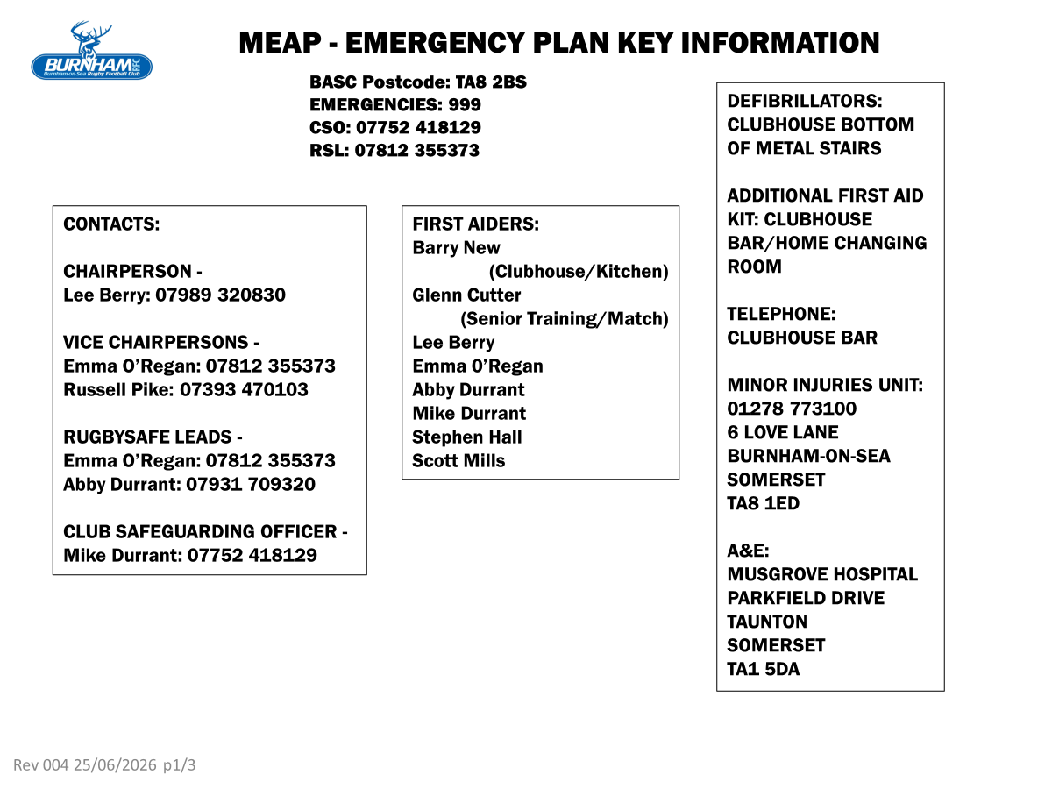

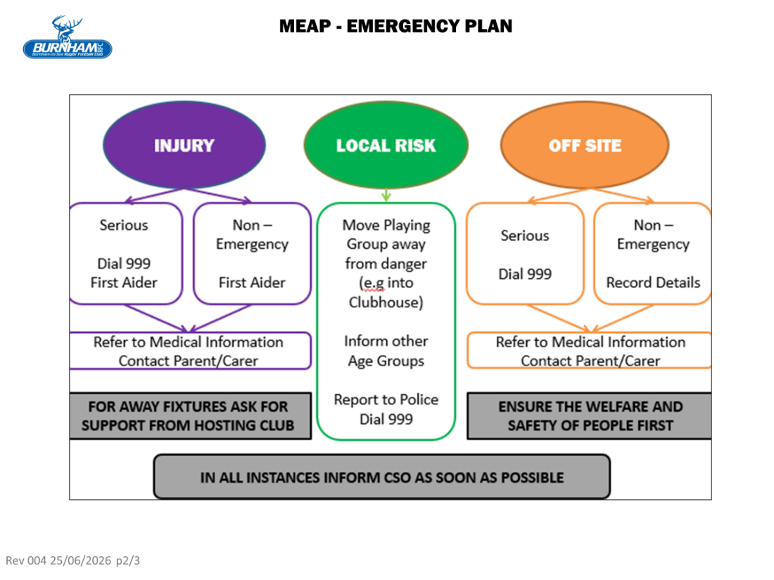

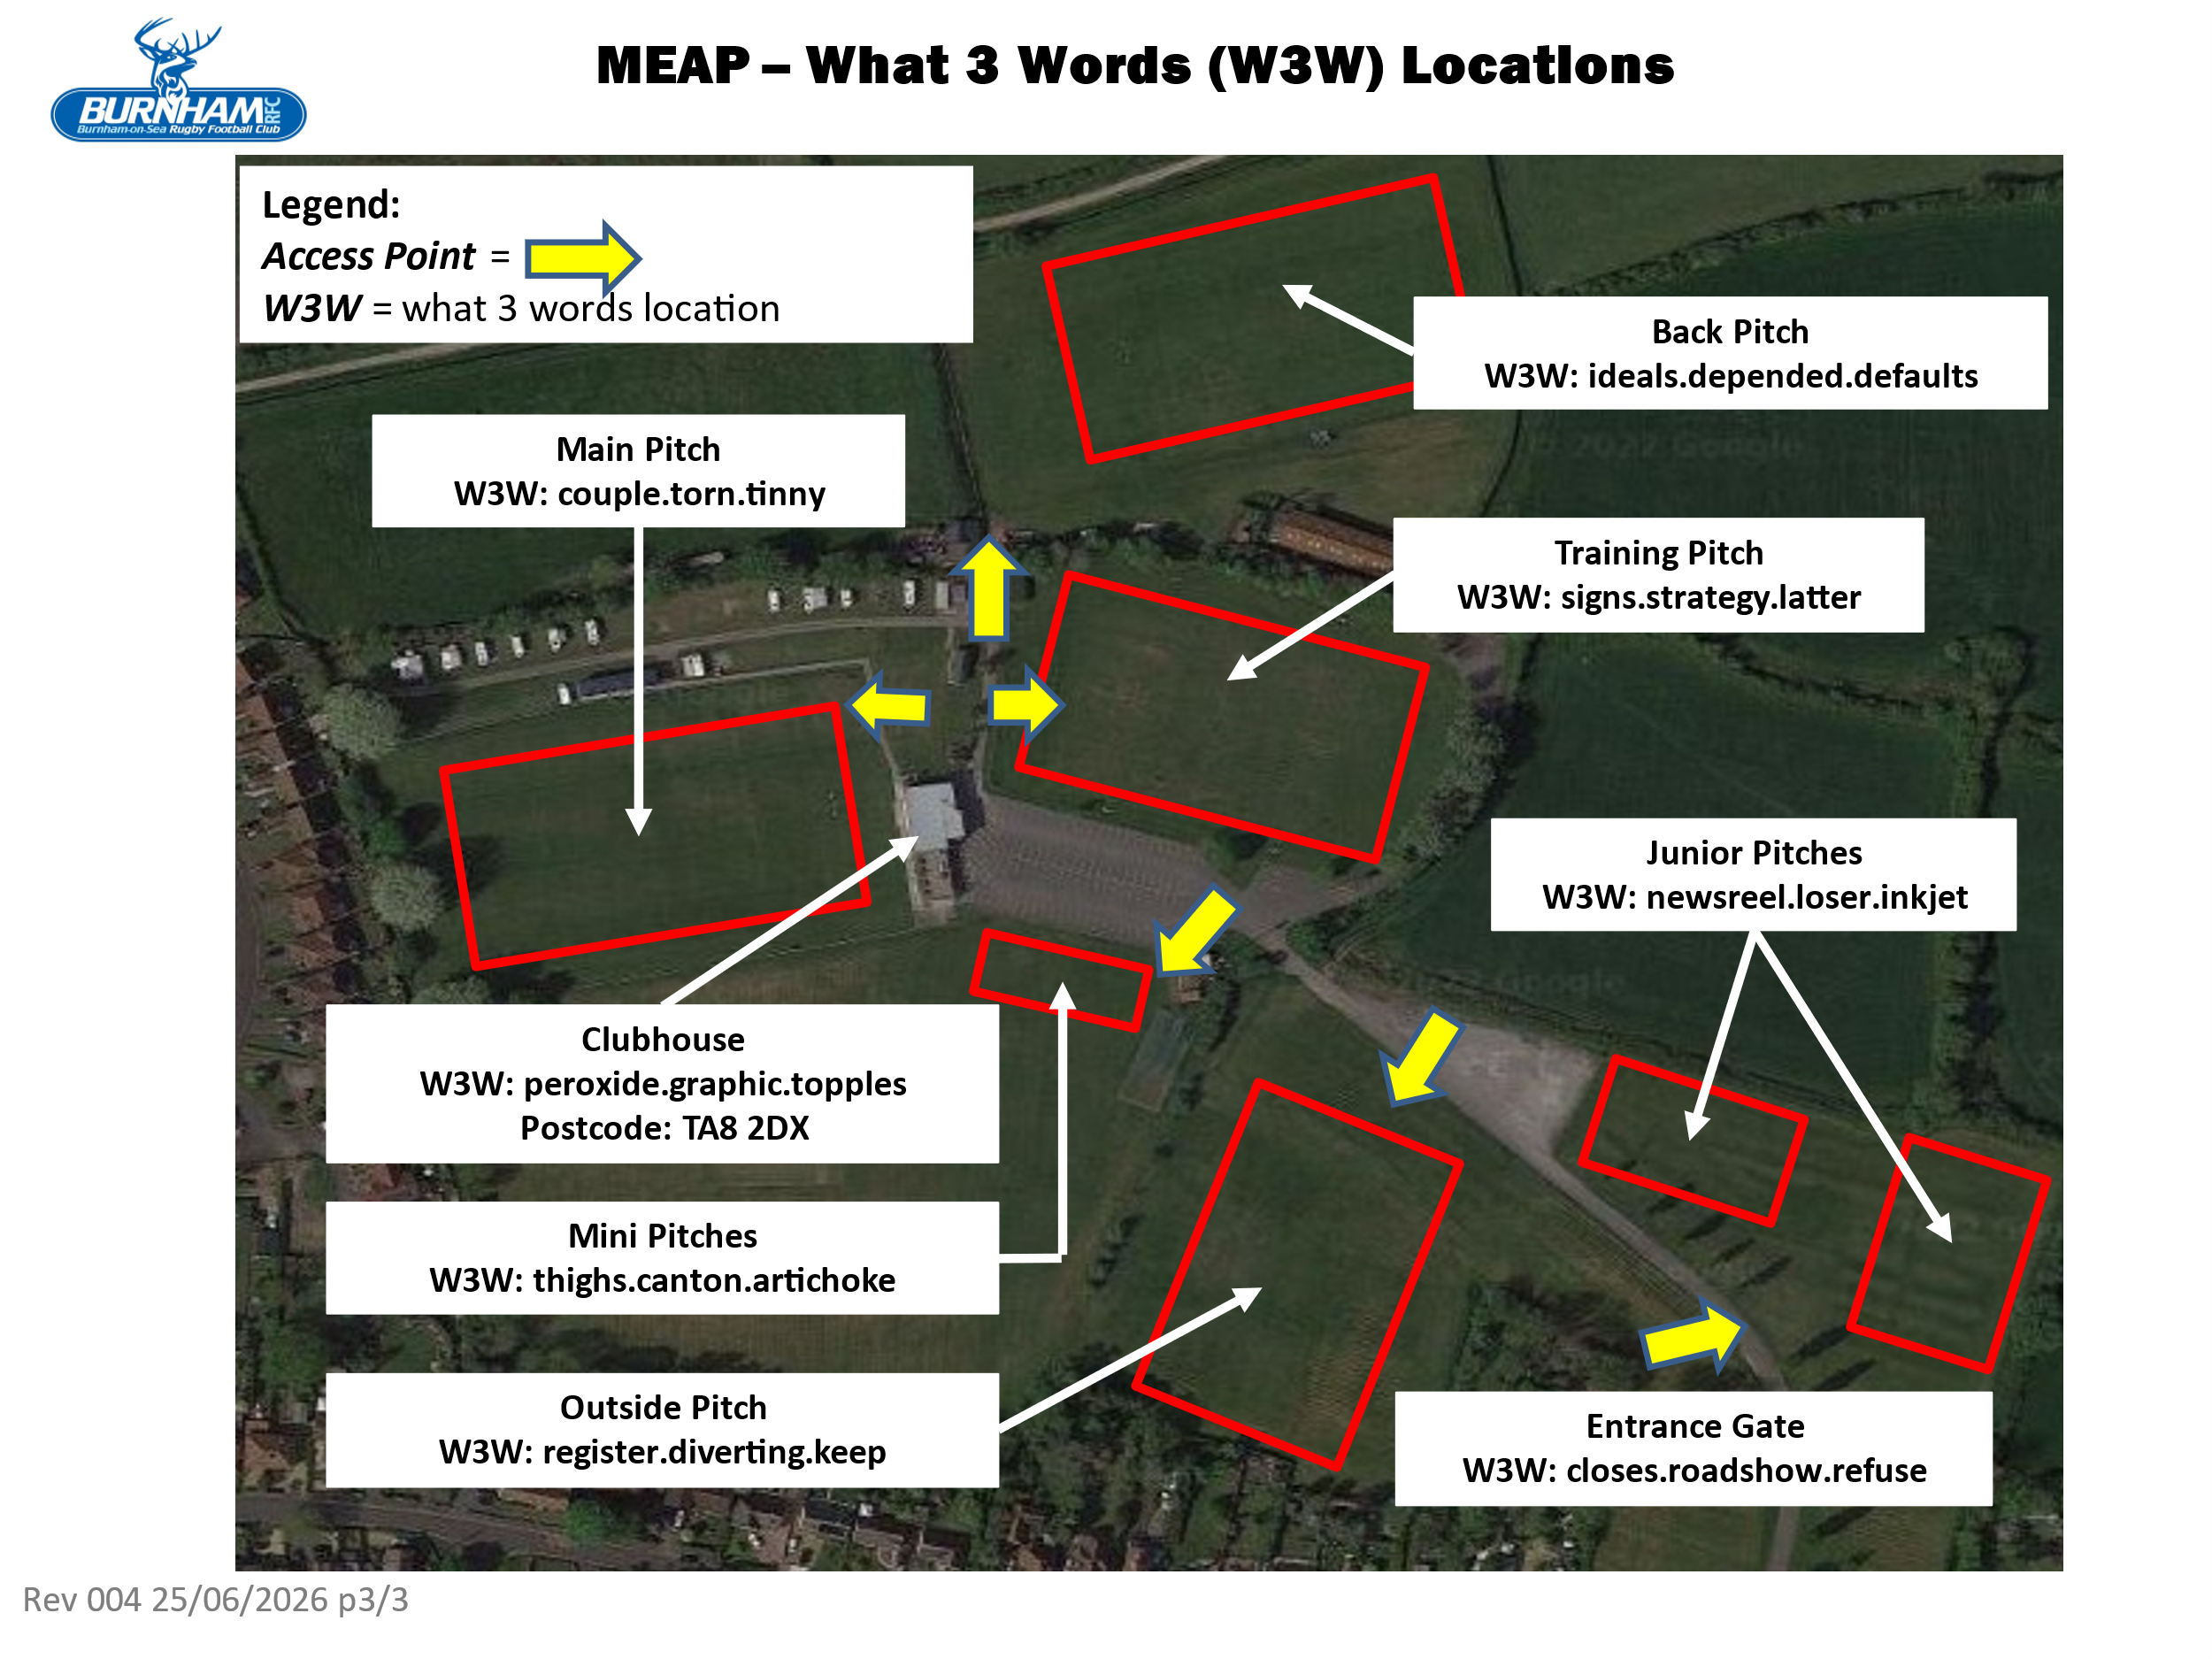

Links and Information
RFU Regulations
https://www.englandrugby.com/governance/rule s-and-regulations/regulations
(Age Grade Regulation 15 and Safeguarding Regulation 21)
RugbySafe and Safeguarding
https://www.englandrugby.com/participation/pla ying/player-welfare-rugby-safe
https://www.englandrugby.com/governance/safe guarding
https://www.englandrugby.com/governance/safe guarding/safer-recruitment/dbs-information-forapplicants
Coaching and Courses
https://www.englandrugby.com/participation/co aching
https://www.englandrugby.com/participation/co aching/booking-a-course
https://www.englandrugby.com/participation/co aching/coach-resources
https://www.youtube.com/channel/UCZ9bbrNmWFQYsAR0NKIi8Q (Keep Your Boots On)

